2014 Highlight

Repeat as appropriate if the highlight reports results of more than one award:
{
Award Number: 0746816 and REU supplement 1341256
PI Name(s): Amy McGovern
Contact Email Address(es): amcgovern@ou.edu
Institution(s): University of Oklahoma
Award Title: NSF CAREER: Developing Spatiotemporal Relational Models to Anticipate Tornado Formation
Total Award Amount: $500,000
Starting Date: 07/01/2008
Expected Expiration Date: 06/30/2015
Primary Supporting NSF Directorate, Division, Program: CISE
Cognizant Program Director's Name: Maria Zemankova
Other Supporting NSF Directorate(s), Division(s), Program(s):
NSF Press Release Associated with This Highlight (xx-xxx) :
}

Title of your Highlight:
(Please provide a descriptive, compelling title – it need not be the same as the title of the award(s))
Weather App Puts Kids in the Pilot Seat

What is the outcome or accomplishment?
(1-2 short sentences describing it and why it is transformative; 50 word max. suggested)
NOTE: Insert only text and do not include images. Instructions for providing images are below.

Example: A team of scientists has shown that a rock from Antarctica is identical to a band of rocks in western North America, implying that the two continents were once adjacent to one another.

A team of computer scientists and meteorologists at the University of Oklahoma have developed a weather game to teach kids about technology and weather.

What is the Impact:
(1-2 simple sentences describing the benefits for science, industry, society, the economy, national security, etc; 50 word max. suggested)

Example: Determining the past configuration of the continents can serve many purposes, including modeling past climates, understanding evolution, and helping to locate natural resources.

Kids can learn about weather radar and what a severe storm looks like, hopefully teaching them concepts important for saving lives. They also learn about the uses of technology for real-world applications, specifically weather prediction for airplanes.

What explanation/background does the lay reader need to understand the significance of this outcome?
(1-2 paragraphs that might include, for example, more on who, when, where; NSF's role; support from multiple directorates/offices; what makes this accomplishment unique; additional intellectual merits; or broader impacts such as education, outreach, or infrastructure improvement that are integral to this outcome; 150 word max. suggested)

Example: We currently have a good understanding of the last amalgamation of continents called Pangea, which existed from 545 to 180 million years ago and allowed land-dwelling organisms to proliferate across the globe. However, we have poor information on the previous amalgamation--Rodinia--which formed about 1.3 billion years ago. Determining Rodinia's characteristics are key to understanding the origins of complex life on Earth, as well as understanding the snowball Earth period, when the entire globe froze over.

The rock study, conducted by a multi-university team, supports the juxtaposition of East Antarctica with western Laurentia at that time. Laurentia is the continent that, at the time, included the landmasses now known as North America and Greenland. Previously, scientists had suggested that China or Siberia had been adjacent to this coast.

Kids growing up in tornado alley are used to bright, splotchy radar patterns moving across a television screen, and most know the difference between a tornado watch and warning. But do they understand how to read and predict the weather based on radar images and forecasts? Students at the University of Oklahoma’s College of Engineering wanted to remove the mystery around weather forecasting by speaking to kids in a language they could better understand – gaming. Collaborating with the School of Meteorology, OU students created an app that teaches kids about weather patterns by putting them in the pilot seat to navigate a plane during weather events. The game encourages kids to see meteorology as a problem-solving tool rather than just a segment of the evening news.

With funding from a more than $600,000 National Science Foundation grant, Amy McGovern, OU associate professor of computer science and adjunct associate professor of meteorology, and engineering students Andrea Balfour, David Harrison and Marissa Beene created Storm Evader, an iPad app aimed at elementary and middle school students. The app challenges players to route airplanes from one U.S. airport to another while avoiding pitfalls like difficult weather patterns and long routes that waste fuel.

The app features two modes of game play – free play and career play. In free play mode, players fly their planes during actual recorded severe weather events, including the widest tornado documented in history in El Reno, Oklahoma. In career mode, players are encouraged to delve deeper by researching weather forecasts before deciding the safest route for their planes. In both modes, players can give control to the computer to help find the best route to the correct airport.

“We want to teach kids about weather in a fun and interactive way,” said Harrison, a sophomore majoring in meteorology with a minor in computer science. “In Storm Evader kids see how weather forecasting and radar works in real-life and can actually solve problems.”

At the National Weather Festival held last November in Norman, the team presented the app to a group of more than 500 children, letting them play the game and provide feedback. The results confirmed their hypothesis that the app would appeal to a younger demographic, but in less formal testing, the team was surprised to learn that older ages benefit too.

“The app’s advanced forecasting features remind adults how weather affects everyday situations,” said Balfour, a sophomore majoring in computer science and meteorology. “Knowing how to read and understand weather forecasts can be helpful and even necessary.”

Encouraged by Storm Evader’s success, the team is already creating another weather-related app. It focuses on teaching kids how tornados evolve and how to be prepared in severe weather situations. McGovern is pleased with her team’s results, especially since they are still early in their academics.

“When they were creating Storm Evader, these students hadn’t even taken advanced computer science courses,” McGovern said. “Their work beat all my expectations, and they have a done a great job proving that technology can be used to make sense of everyday situations.”

Storm Evader is available for iPad and is free in the app store on iTunes.

Add Image(s)‏:
- Submit photos or other images that illustrate the outcome described, show research or education in action, and are clearly understandable by a general audience.
- Photo or image resolution should be as high as possible; preferably, 300 dpi and at least 1500 pixels per side.
- File type can be JPEG, GIF, or TIF and should be provided as an attachment.
- Filename needs to follow the following format:
PILastName-AwardNumber-image#.XXX
Examples: Jones-1234567-image1.JPEG; Jones-1345678-image2.GIF
- Video is also welcome but there are additional requirements. To learn more about video requirements, please contact highlightshelp@nsf.gov.
- View examples at www.research.gov/seeinnovation

Repeat as appropriate for more than one image:
{
Image#: 1
File Name: StormEvaderPeople.jpg

Insert your image (size at most 3" x 3"):

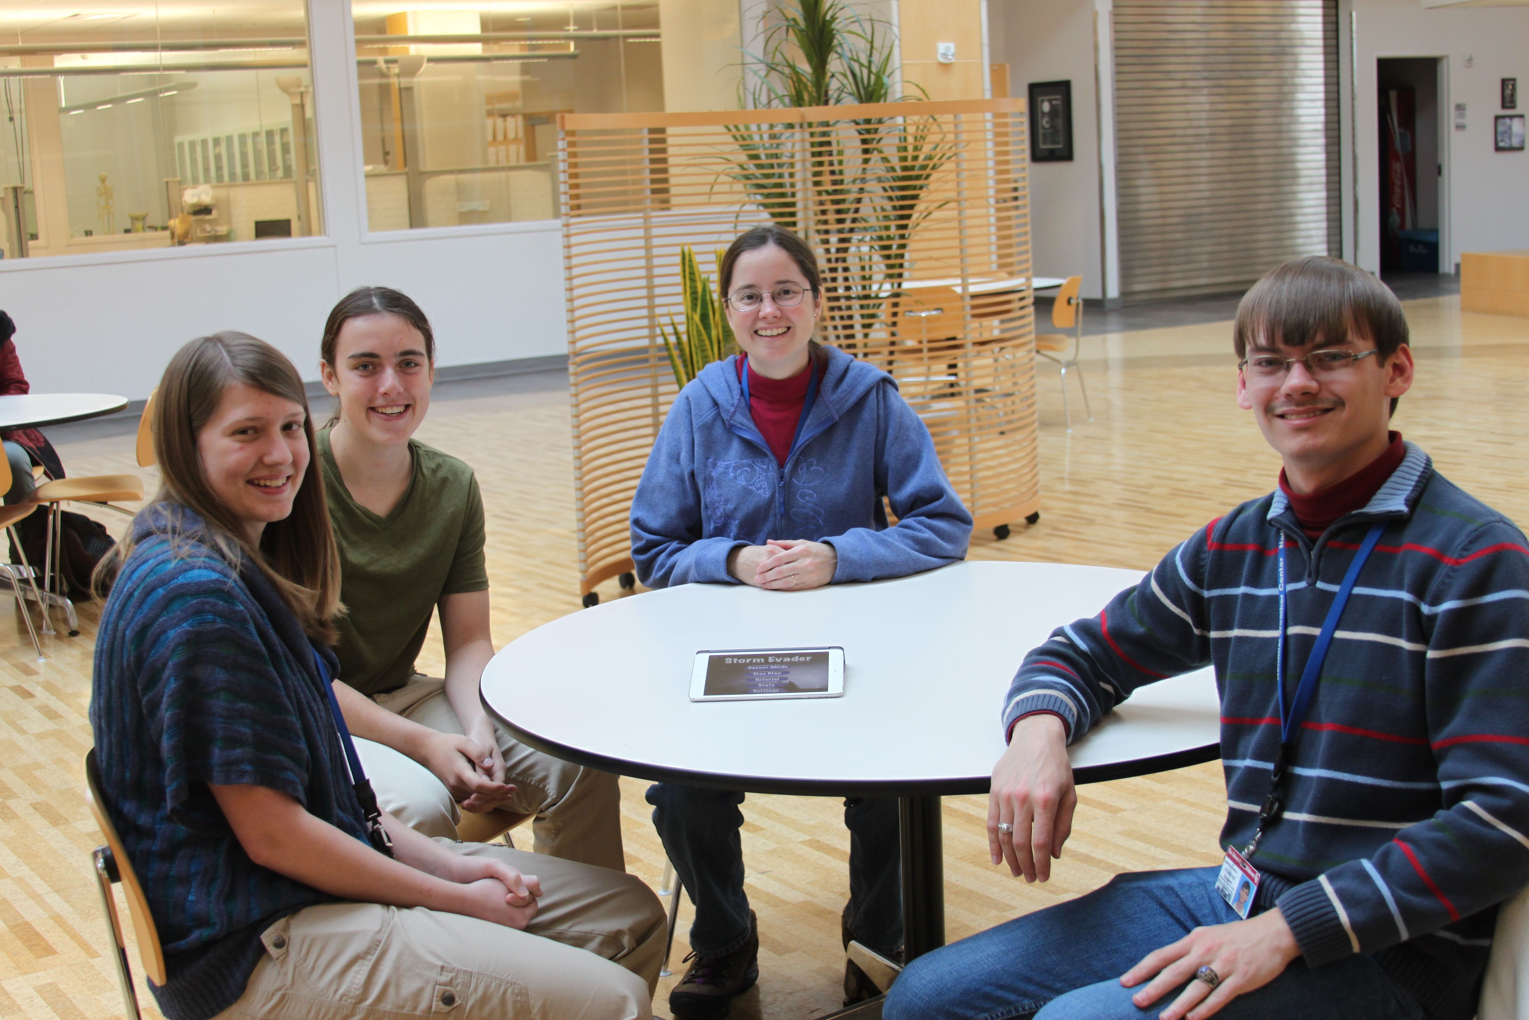

What is your suggested Caption/Description for the image?
(25 word max. suggested per caption)
Example: Researchers collect rock samples in the TransAntarctic Mountains.
OU College of Engineering professor Amy McGovern and students (L-R) Andrea Balfour, Marissa Beene and David Harrison create Storm Evader, a gaming app that helps kids understand weather patterns.
}

{
Image#: 2
File Name: Storm Evader screen shot.png

Insert your image (size at most 3" x 3"):

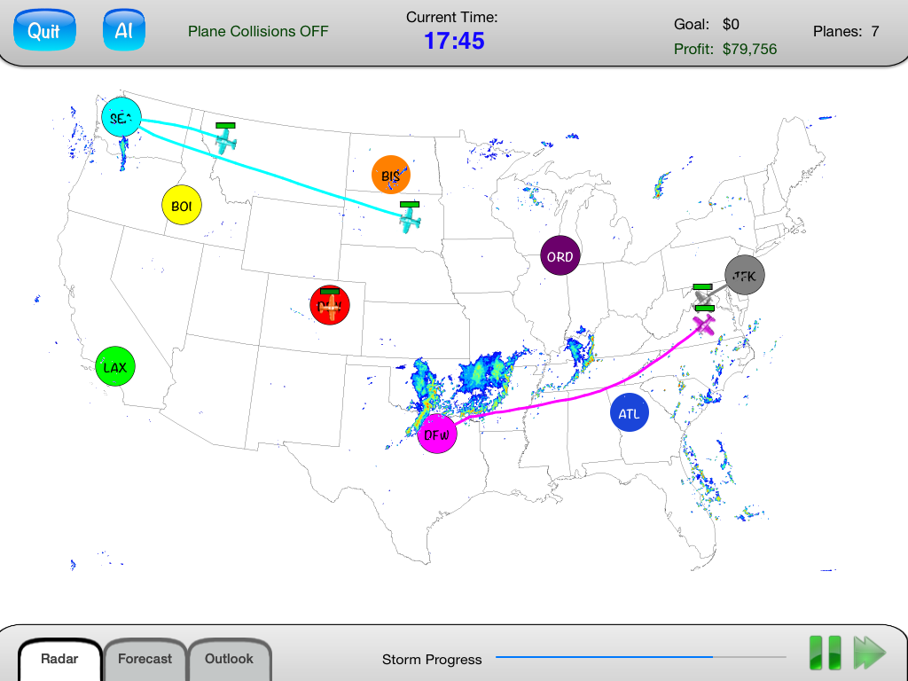

What is your suggested Caption/Description for the image?
(25 word max. suggested per caption)
Example: Researchers collect rock samples in the TransAntarctic Mountains.
Image from Storm Evader. Students fly airplanes around the May 21 tornado in El Reno, Oklahoma, the widest tornado in recorded history.
}

NSF Form 1515: Multimedia Permission & Use of Copyrighted Material:
- For images or video, please obtain permission from the copyright holder -- usually the person who took the photos or created the illustrations -- to allow NSF use them publicly.
- Please fill out and attach the Form 1515 (NSF Form 1515: Multimedia Permission & Use of Copyrighted Material). (One form can be used for multiple images from the same copyright holder. )
- Email the form(s) as a PDF file attachment, using file name(s) of the form:
PILastName-AwardNumber-image#-NSF1515.PDF
Example: Jones-1234567-image1-NSF1515.PDF

Specify email address for individual who provided the image:

